[Address]
[city], ON

Total Above Grade Exterior ft²
Approx Above Ground Exterior Area = 2225.45 ft²

Total Exterior ft²
Approx Exterior Area (basement included) = 2875.81 ft²

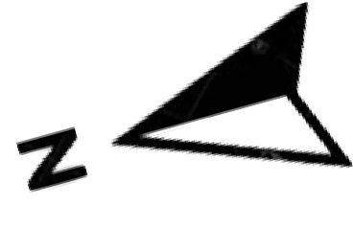
Attic/Loft
(above grade)

Approx Interior Area = 683.11 ft² Approx Exterior Area = 808.59 ft²

All room dimensions and floor areas must be considered approximate and are subject to independent verification.

Lidar iScan by VOGELcreative.com

